Courses

Courses are the spaces on Moodle where [teachers](https://docs.moodle.org/31/en/Teacher) add learning materials and activities for their students. Courses may be created by [admins](https://docs.moodle.org/31/en/Administrator), [course creators](https://docs.moodle.org/31/en/Course_creator) or [managers](https://docs.moodle.org/31/en/Manager). Teachers can then add the content and re-organise them according to their own needs.

# Module: Adding a new course

## Feature: Using an existing course as a template

First, create or locate on your Moodle the course you wish to use as a template and make a note of its short name. A template course might for example have common headings or section summaries or policy agreements used throughout the site for consistency. Note that only the content of the course will be restored and not its settings. Settings are added separately.

* Create your csv file. See [Upload courses](https://docs.moodle.org/31/en/Upload_courses) for accepted fields.
* From Site administration>Administration>Courses>Upload courses, add your file.
* Preview it and scroll down to 'Course process'. In the box 'Restore from this course after upload', add the short name of your template course.
* If you are creating several courses using the same template and you wish them all to have the same settings, you can specify these in the Default course values.
* Upload your csv file.

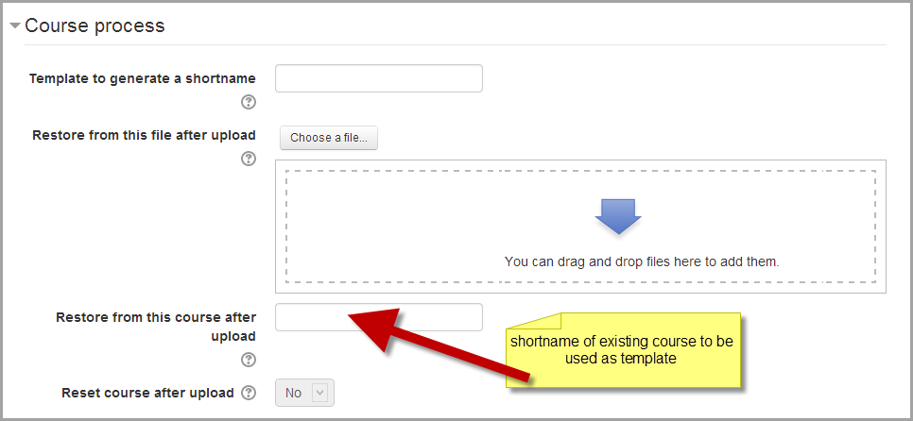

# Module: Course Settings

## Feature: Course Format

(These settings are collapsed by default.)

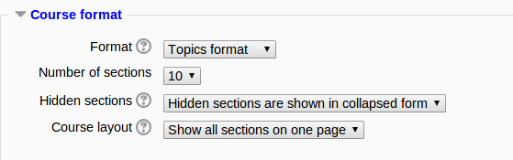

# Problem

Suppose you used the feature “Adding a new course> course templates> using an existing course as a template” to create your new course. However, as mentioned in the feature description, it copies the content only and not the settings. Suppose you want to add the same capability for the “course format” feature to enable you to use the same format of the template course that you used, while creating your new course.

Write a feedback documenting that enhancement to the development team.